POCKETSMART AI
PROJECT DOCUMENTATION
Smart Budget & Recommendation Assistant

iNTRODUCTION
PocketSmart AI is an AI-powered budget and recommendation assistant that helps users plan home interiors, parties, and jewelry purchases. It uses Google Gemini AI to provide personalized recommendations, estimated costs, and shopping links based on users’ budgets and preferences

Problem Statement
People often struggle to manage their budgets when planning home interiors, party events, or buying matching jewelry/outfits. Searching through multiple websites manually to fit items within a specific budget is time-consuming and confusing.

The Solution
PocketSmart AI automates this process by using Gemini 3.5 Flash-Lite to analyze user preferences, budget constraints, and multimodal inputs (like outfit images) to recommend tailored products and budget allocations instantly.

Features
- Home Interior Budget Planner: Helps users budget and source room furniture, lighting, and appliances from platforms like IKEA and Amazon.
- Party Budget Planner: Automatically allocates funds across catering, venue, decorations, and entertainment based on guest count and event type.
- Jewelry & Outfit Matching Planner: Analyzes outfit images using Gemini's multimodal features to recommend matching jewelry options within the user's budget.

Technical Architecture & Stack
- AI Model: Google Gemini 3.5 Flash-Lite - used to generate budget-based recommendations and analyze outfit images.
- Backend: Python with FastAPI.
- Frontend: HTML5, CSS3, JavaScript, and Jinja2 templates.
- SDK / API: Google Gen AI SDK (google-genai) for connecting to Gemini.
- Image Processing: Outfit images are uploaded and sent to Gemini for analysis.

Data Flow Diagram
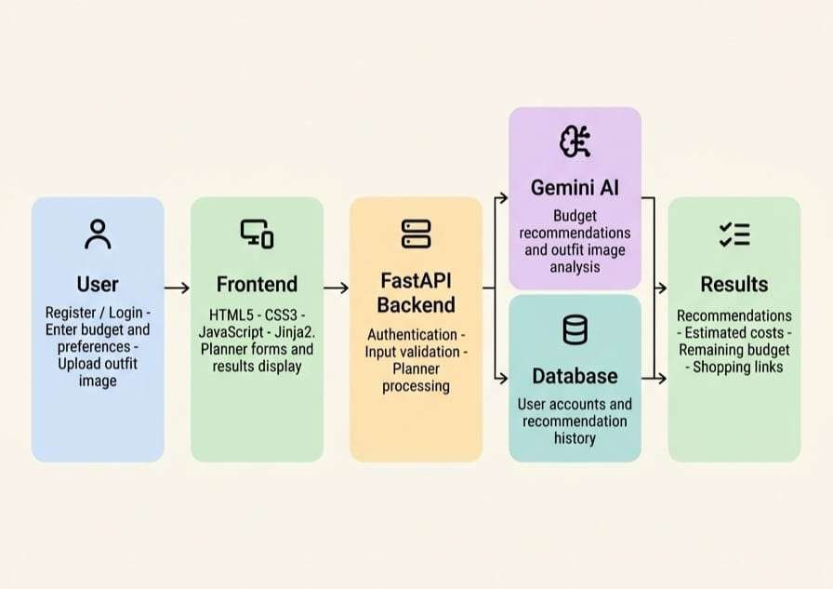

Application Workflow

PocketSmart AI is an AI-powered application that helps users plan purchases within their budget. It provides personalized recommendations through three planners.

User Login or Registration
The user creates an account or logs in to access the application.

Select a Planner
The user chooses one of three options: Home Interior Planner, Party Planner, or Jewelry
Planner.

Enter Requirements
The user provides details such as budget, preferences, event type, number of guests, or occasion. The Jewelry Planner also supports an optional outfit image.

AI Recommendation Generation
The application sends the user's requirements to Google Gemini AI, which generates personalized recommendations based on the provided details.

View Recommendations
The application displays recommended items, quantities, estimated prices, total costs, and shopping links.

Review and Plan
Users can compare recommendations with their budget and review their previous recommendations through the history feature.

Example
If a user enters a budget of ₹10,000 in the Home Interior Planner, PocketSmart AI suggests suitable items and estimates their costs. If the estimated total is ₹8,500, the application shows that ₹1,500 remains in the budget.

In summary: PocketSmart AI collects the user's requirements, uses Google Gemini AI to generate recommendations, and presents budget-based results through a simple interface.

Planning, Design, and Development
- Planning
The planning phase focused on identifying the problem of managing budgets while purchasing products and planning events. The project scope was defined around three main features: Home Interior Planner, Party Planner, and Jewelry Planner. The project milestones, requirements, and development activities were organized to guide the implementation.

- Design
The design phase focused on creating the system architecture, application workflow, and user interface. The application was designed with a simple and user-friendly interface, including account registration, login, planner forms, and recommendation result pages. The workflow connects user inputs with the AI recommendation process.

- Development
The development phase involved building the PocketSmart AI application using Python and FastAPI for the backend, HTML, CSS, JavaScript, and Jinja2 for the frontend, and Google Gemini AI for generating recommendations. The three planners were implemented with budget-based recommendations, estimated costs, and shopping links. User authentication, recommendation history, input validation, and fallback recommendations were also included.

Advantages
  - Budget-Friendly Planning:
  - Personalized Recommendations.
  - Multiple Planning Options
  - Cost Estimation: Displays
  - Time-Saving
  - Shopping Links
  - User-Friendly Interface
  - Recommendation History
  - Image-Based Assistance
  - Fallback Recommendations

Project Structure- Description
    - app/ – Contains the main application and backend logic.
    - routes/ – Handles login, registration, and planner requests.
    - services/ – Contains Gemini AI integration and recommendation logic.
    - models/ – Defines data structures and database models.
    - database.py – Manages database connections.
    - templates/ – Contains the HTML pages displayed to users.
    - static/ – Stores CSS, JavaScript, and image files.
    - .env – Stores the Gemini API key and other private settings. Do not upload it to GitHub.
    - .env.example – Provides a template for environment variables.
    - requirements.txt – Lists the Python dependencies.
    - README.md – Explains the project and how to run it.
    - pocketsmart.db – Stores local application data.

Project Structure:
PocketSmart_AI/
│
├── app/
│ ├── main.py
│ ├── routes/
│ │ └── planners.py
│ ├── services/
│ │ └── gemini_service.py
│ ├── models/
│ │ └── schemas.py
│ ├── database.py
│ └── auth.py
│
├── templates/
│ ├── login.html
│ ├── register.html
│ ├── home.html
│ ├── party.html
│ └── jewelry.html
│
├── static/
│ ├── css/
│ │ └── style.css
│ └── js/
│ └── script.js
│
├── .env
├── .env.example
├── .gitignore
├── requirements.txt
└── README.md

Future of PocketSmart AI
In the future, PocketSmart AI can be enhanced by adding more planning categories, real-time product prices, product comparisons, and personalized recommendations based on user preferences. It could also be developed into a mobile application and integrated with more shopping platforms. These improvements would make PocketSmart AI more useful, accessible, and reliable, helping users plan their purchases efficiently while staying within their budgets.

Conclusion
PocketSmart AI is an AI-powered budget and recommendation assistant developed using Python, FastAPI, Google Gemini AI, HTML5, CSS3, JavaScript, and Jinja2 templates. It helps users plan home interiors, parties, and jewelry purchases based on their budgets and preferences by providing personalized recommendations, estimated costs, remaining budget details, and shopping links. The application also includes user authentication, recommendation history, and fallback recommendations when AI services are unavailable. Through this project, practical knowledge of Generative AI integration, web development, database management, and software testing was demonstrated. Overall, PocketSmart AI simplifies everyday planning and supports budget-conscious decision-making.

